Tutorial -2

Discuss Basic Linux Command

1. who - displays a list of users who are currently logged into the computer.

Syntax:

who

who am i

who [options] [File] who --help

who --version

who | grep 'userNameHere'

Description:

You need to use who command to display users who are currently logged in your server.

Find who is on the system

Use of Command:

|  |  |
| --- | --- |
| Option | Use |
| -H | To display line of column headings |
| -m | To show only hostname and user associated with stdin |
| -p | To show active processes spawned by init |
| -T | To show user’s message status as +, – or ? |
| -u | Type the command |
| -b | To display time of last system boot |
| -d or -d -H | You need pass to show dead processes |
| -l or -l -H | To just display system login processes |
| -q | To count all login names and number of users logged on |
| -r | To count all login names and number of users logged on |
| -r -b | You can combine display current runlevel |

Example:

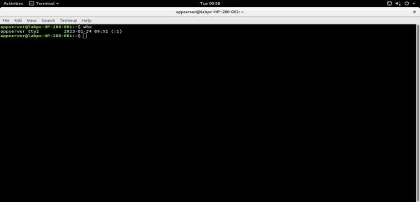

1. who am i - displays the username of the current user when this command is invoked

Syntax:

whoami [OPTION]

Description:

whoami command is used both in *Unix Operating System* and as well as in *Windows Operating System*.

* + It is basically the concatenation of the strings “who”,”am”,”i” as whoami.
  + It displays the username of the current user when this command is invoked.
  + It is similar as running the id command with the options -un.

Use of Command:

|  |  |
| --- | --- |
| Option | Use |
| whoami --help | gives the help message and exit |
| whoami --version | gives the version information and exit |
| w | Show who is logged on and what they are doing |
| who | Report which users are logged in to the system |

Example:

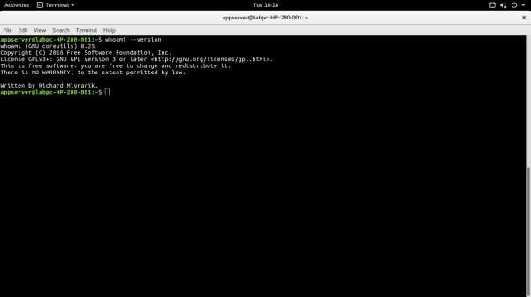

1. mkdir- allows users to create or make new directories. *mkdir* stands for “make directory.”

Syntax:

mkdir [option] dir_name

**Description:**

mkdir stands for 'make directory'. With the help of mkdir command, you can create a new directory wherever you want in your system. Just type "mkdir <dir name>, in place of <dir name> type the name of new directory, you want to create and then press enter.

**Use of Command:**

|  |  |
| --- | --- |
| Option | Use |
| mkdir -p, -parents | Add directory including its sub directory |
| mkdir -v, -verbose | Print a message for each created directory |
| mkdir -m -mode=MODE | Set access privilege |

**Example:**

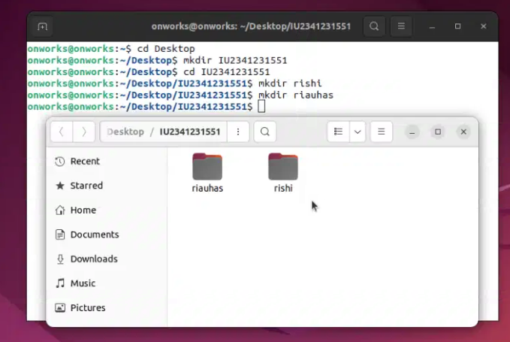

1. **rmdir**- used to delete a directory.

**Syntax:**

rmdir <dirname>

**Description:**

This command is used to delete a directory. But will not be able to delete a directory including a sub-directory. It means, a directory has to be empty to be deleted.

Use of Command:

* -p: This option removes the directory, including all its ancestors
* -v, –verbose: Displays verbose information for every directory.
* –ignore-fail-on-non-empty: This option does not report a failure that occurs because a directory is non-empty.
* –version: This option displays the version information and exit.

**Example:**

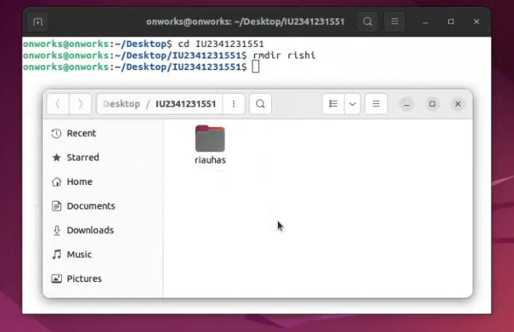

1. **cd**- used to change the current working directory

**Syntax:**

cd <dirname>

**Description:**

The "cd" stands for 'change directory.' It is one of the most frequently used commands in the Linux terminal.It is one of the most important and common commands in the [Linux](https://www.javatpoint.com/linux-tutorial) system and will be used repeatedly.

**Use of Command:**

* cd / : To go to the root directory, we input / as the argument.
* Cd : We do not provide any arguments to the cd command to go to the home directory.
* cd . . : To shift one level above the current directory, we input .. as the argument.
* cd - : To go to the previous directory, we use - as our argument.
* cd /folder/subfolder : For custom navigation across any directory, we can send its path as the argument.

**Example:**

1. **touch-** uses to create empty files

**Syntax:**

touch <filename>

**Description:**

Two files namely 'myfile1' and 'myfile2' through touch command. To create multiple files just type all the file names with a single touch command followed by enter key. For example, if you would like to create 'myfile1' and 'myfile2' simultaneously.

**Use of Command:**

* -a: Change the access time
* -m: Change the modification time
* -c: Prevent creating a new file
* -h: Change the symbolic link timestamp
* -h: Change the timestamp for symbolic links
* -t <stamp>: Modify the timestamp. In this case, <stamp> follows the date-time format
* -d=<string>: Change the timestamp based on the date string
* -r=<file>: Change the timestamp based on the reference file
* -v or –version: Display the touch command version
* –help: Display the help menu

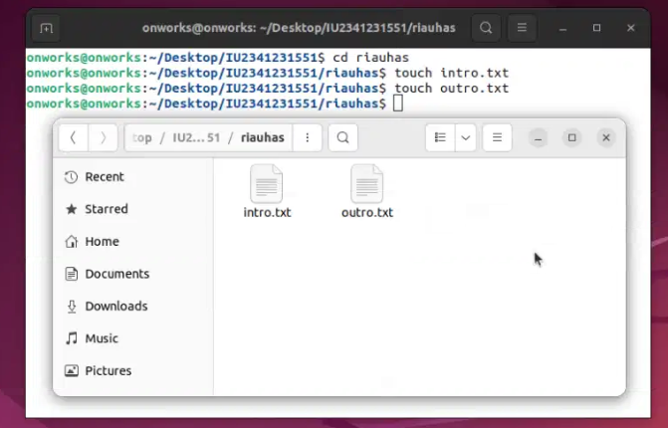**Example:**

1. **cat-** Can be used to create, write and view data into files.

**Syntax:** cat file_name

Description: The 'cat' command is the most universal and powerful tool. It is considered to be one of the most frequently used commands. It can be used to display the content of a file, copy content from one file to another, concatenate the contents of multiple files, display the line number, display $ at the end of the line, etc.

**Use of Command:**

* -b Omits line numbers from blank lines, when specified with the -n flag.
* -e Displays a $ (dollar sign) at the end of each line, when specified with the -v flag.
* -n Displays output lines preceded by line numbers, numbered sequentially from 1.
* -q does not display a message if the cat command cannot find an input file.
* -r replaces multiple consecutive empty lines with one empty line.

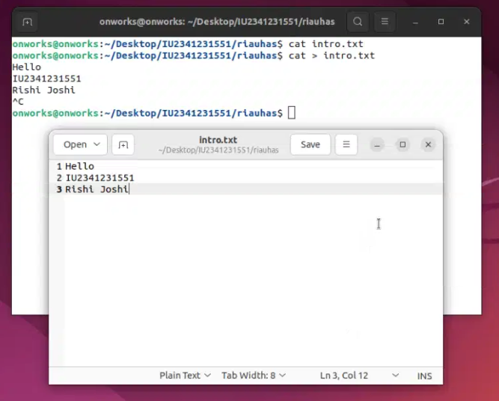**Example:**

1. **cp**- cp command is used for copy file.

**Syntax:**

cp file_name file_name2

**Description:** The key tool for this task is the “cp” command. In this simple guide, we’ll explore how to copy a file in Linux, looking at the basic steps, different choices you can make, and giving clear examples. We’ll also take a peek behind the scenes to understand how the “cp” command works. Let’s get started on this easy journey to become familiar with the ins and outs of copying files in Linux!

**Use of Command:**

* -f: Forces a copy in all circumstances.
* -i: Runs cp in interactive mode. In this mode, Linux asks for confirmation before overwriting any existing files or directories. Without this option, Linux does not display any warnings.
* -p: Preserves the file attributes of the original file in the copy. File attributes include the date stamps for file creation and last modification, user ID, group IP, and file permissions.
* -R: Copies files recursively. All files and subdirectories in the specified source directory are copied to the destination.
* -u: Overwrites the destination file only if the source file is newer than the destination file.

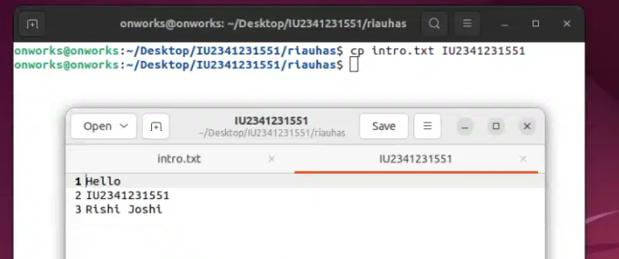**Example:**

1. **rm-** rm is used to remove or delete files.

**Syntax:**

rm file_name

**Description:**

rm is a general command in Unix and other Unix-like systems. It is used to delete objects like symbolic links, directories, and computer files from the file systems.

**Use of Command:**

* -f or –force: This forces the files to be deleted and will not ask for confirmation. You should, generally avoid using this option since it has huge potential to go wrong.
* -i or –interactive: Ensures that before anything is deleted it needs to be confirmed. Only once confirmed will the corresponding file be deleted. This prevents any unwanted data being deleted.
* -r, -R or –recursive: This causes a recursive deletion. In other words alongside the actual directory to be deleted all subfolders and files are removed. However, using this option can also be dangerous.
* -v or –verbose: This will show what the command is currently doing.

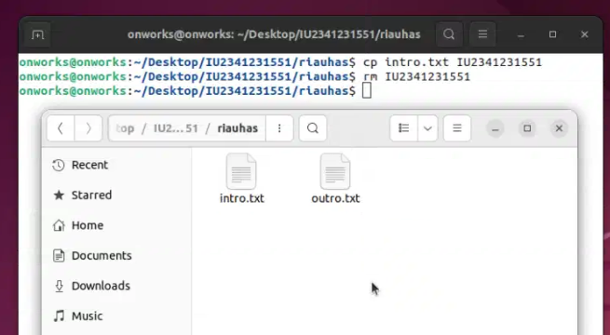**Example:**

1. **pwd** - pwd is used to retrieve path of the file.

**Syntax:**

pwd file_name

**Description:**

pwd command displays the Absolute path of the current directory. This command shows where the Terminal currently is in detail and will help you when you are lost inside some unknown directory.The command pwd also has an environment variable. You can access this variable by using $PWD in the Terminal.

Use of Command:

* -L Uses PWD variable from the environment. If it contains a symlink, this command will then process that symlink.
* -P Avoids any type of symlinks and shows only the current directory path.
* –help Provides help on the available options for the pwd command.

**Example:**

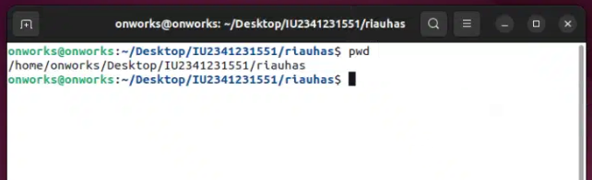

1. **clear**- clear is used to remove previous commands

**Syntax:** clear

**Description:**

The clear command clears your terminal screen if possible. It also scrolls down the terminal screen to clear it. It observes the terminal type in the environment given by the environment variable TERM, and then in the terminfo database to decide how the screen can be cleared. Standard output is also written by the clear command in Linux.

Use of Command:

* -T, Indicates the type of terminal
* -V, Reports the version of ncurses
* -x, Scrolls down the terminal, does not remove history

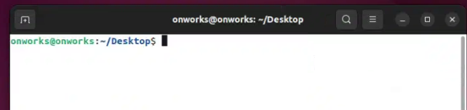Example:

1. **exit**- exit is used to exit the terminal

**Syntax:** exit

**Description:**

The exit command is used to end or close the current login session in the Linux ecosystem. Shell or bash jobs as well as the Linux CLI can be closed using this simple command.

Example:

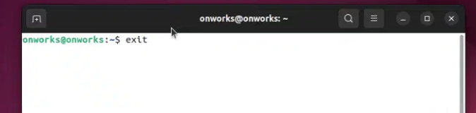

1. **uname**- uname returns user name.

**Syntax**: uname

**Description:**

The uname command writes to standard output the name of the operating system that you are using. The machine ID number contains 12 characters in the following digit format: xxyyyyyymmss. The xx positions indicate the system and is always 00. The yyyyyy positions contain the unique ID number for the entire system.

Use of Command:

* -a --all Prints all system information.
* -s --kernel-name Prints the Kernel name.
* -n --nodename Prints the network node hostname.
* -r --kernel-release Prints the Kernel release number.
* -v --kernel-version Prints the Kernel version.
* -m --machine Outputs the machine's architecture type.
* -p --processor Prints the CPU type.
* -i --hardware-platform Prints hardware platform type.
* -o --operating-system Prints the operating system name.

Example: